**Circuit diagram: -**

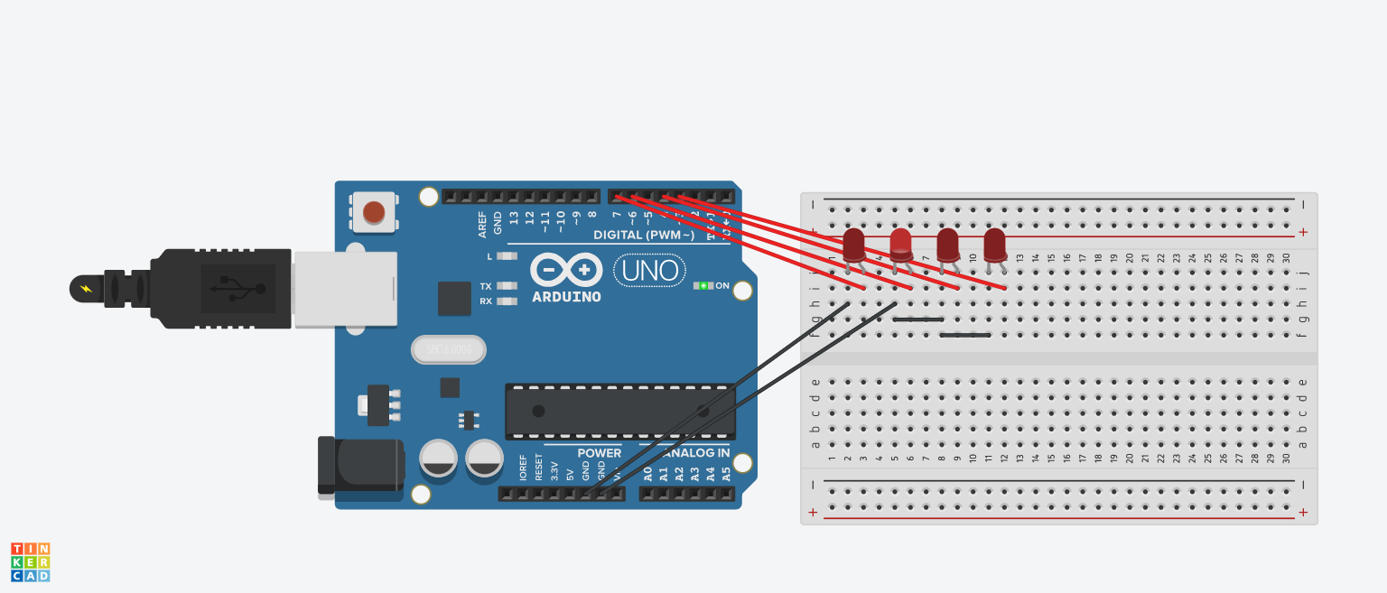

**Theory :-**

**LEDs** are a particular type of diode that convert electrical energy into light. In fact, LED stands for “Light Emitting Diode.” (It does what it says on the tin!) And this is reflected in the similarity between the diode and LED schematic symbols.

In short, LEDs are like tiny lightbulbs. However, LEDs require a lot less power to light up by comparison. They’re also more energy efficient, so they don’t tend to get hot like conventional light bulbs do (unless you’re really pumping power into them). This makes them ideal for mobile devices and other low-power applications. Don’t count them out of the high-power game, though. High-intensity LEDs have found their way into accent lighting, spotlights and even automotive headlights!

The brightness of an LED is directly dependent on how much current it draws. That means two things. The first being that super bright LEDs drain batteries more quickly, because the extra brightness comes from the extra power being used. The second is that you can control the brightness of an LED by controlling the amount of current through it. But, setting the mood isn’t the only reason to cut back your current.

The **Arduino Uno** is an open-source microcontroller board based on the Microchip ATmega328P microcontroller and developed by Arduino.cc. The board is equipped with sets of digital and analog input/output (I/O) pins that may be interfaced to various expansion boards (shields) and other circuits. The board has 14 Digital pins, 6 Analog pins, and programmable with the Arduino IDE (Integrated Development Environment) via a type B USB cable. It can be powered by the USB cable or by an external 9-volt battery, though it accepts voltages between 7 and 20 volts.

**Concept Used :** -

A circuit is made in which four LEDs are connected in series with the resistors and resistors are connected to Arduino Board on different pins. The resistors are used to resist the flow of current in LEDs so that LEDs don’t get damage. The coding for Arduino is done in such a way that when stimulation is started, the LEDs starts blinking with the time gap of 1s one by one in the form of –

   

   

   

   

**Learning and Observations : -**

* Making circuits using Breadboard.
* Connection four LEDs in Series on Breadboard.
* Using Multimeter to apply Resistance on a given LED.
* Working of Arduino UNO.
* Coding to be done on Arduino.exe for stimulation of the experiment.

**Problems & Troubleshooting: –**

No problems were occurred during the execution of the experiment.

**Precautions :–**

1. The circuit made on breadboard can be wrong.
2. Any Element used can be defective.
3. Resistance of high value used therefore resulting in no current for any LED to glow.
4. The coding done for Arduino Board can be incorrect due to which stimulation can be failed.
5. Port Selection for Arduino can be incorrect due to which it wont upload on Arduino Board and resulting in failure of experiment.

**Learning Outcomes: –**

1. Setting up circuit on a Breadboard.
2. Connection four LEDs in Series on Breadboard.
3. Using Multimeter.
4. Working and coding of Arduino and its IDE.

**Result: –**

Chasing of LEDs were verified after uploading the program.